Burp Suite Basics - Lab Report

Date: 02/06/2026
Difficulty: Easy
Category: Web hacking
Platform: TryHackMe

Overview

This lab covers the basics in Burp suite and how to use different tools and features of the application to test web applications for vulnerabilities. The practical aspect of this lab focuses on using Burp proxy to intercept, modify and exploit XSS on a vulnerable web application.

2. Toolset Used

Tool | Purpose / Function
Burp Suite | A tool used for manual testing of web and mobile applications by intercepting, viewing and modifying web requests.

3. What I did

Burp Suite is a Java-based framework designed to serve as a comprehensive solution for conducting web application penetration testing as it has become a tool used for hands-on security testing of websites, mobile apps and API’s (Application Programming Interfaces). It captures and allows manipulation of HTTP/HTTPS traffic between a browser and a web server. You can intercept, view and modify web requests before they reach the target server to manually test a web application. Some key features are described below.

- Proxy: Enables interception and modification of requests and responses while interacting with web applications
- Repeater: Allows capturing, modifying and resending the same request multiple times – used for crafting payloads through trial and error
- Intruder: Used for brute force attacks as it allows bombarding endpoints with requests
- Decoder: It decodes captured information and encodes payloads before sending them to the target
- Comparer: Allows comparison of 2 pieces of data at either the word or byte level
- Sequencer: Assesses the randomness of tokens or session cookies to see how random they actually are

The Burp Suite dashboard has 4 sections – Tasks, Event log, Issue activity and Advisory. Tasks allow you to select background tasks that Burp suite will do while you use the application. Event log gives the information about actions performed by Burp suite such as starting the proxy and any connections made through Burp suite. Issue activity (only available on Burp suite pro) displays the vulnerabilities found by the automated scanner. Advisory gives details about the vulnerabilities. The question mark icons give you information and help about certain sections and processes.

You can navigate through Burp suite using the top menu bars where you can select the module you wish to use. Each module has sub-tabs which are found in the second menu bar that appears after selecting your chosen module. Global settings affect the entire Burp suite installation and are applied every time the application is started. Project settings are specific to the current project and apply only during the session.

Burp Proxy is a fundamental tool within Burp suite as it enables the captures of requests and responses between the user and the target server. This traffic that is captured can then be edited and sent to other tools for further processing. When requests are made through the Burp Proxy, they appear in the proxy tab which allows for forwarding, dropping, editing or sending them. To allow requests to pass the proxy and not be intercepted, click “intercept is on”. It captures and logs requests made through the proxy which helps with analysis and review prior requests. To show how this works, the following practical task was carried out to show FoxyProxy.

On Firefox, there is an extension called FoxyProxy which is used here. In the options settings, we can add a proxy named Burp.

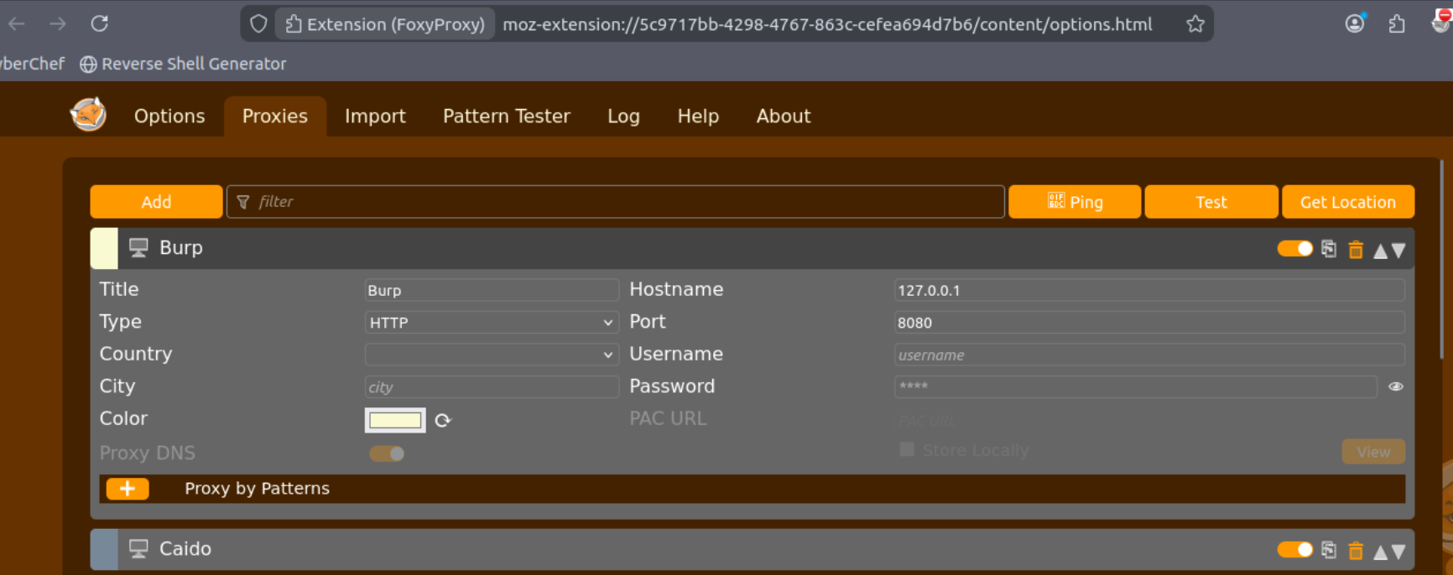

Once this is activated, the “intercept is on” button needs to be active in the proxy tab. When I Open Firefox and make a request such as the one below, it hangs.

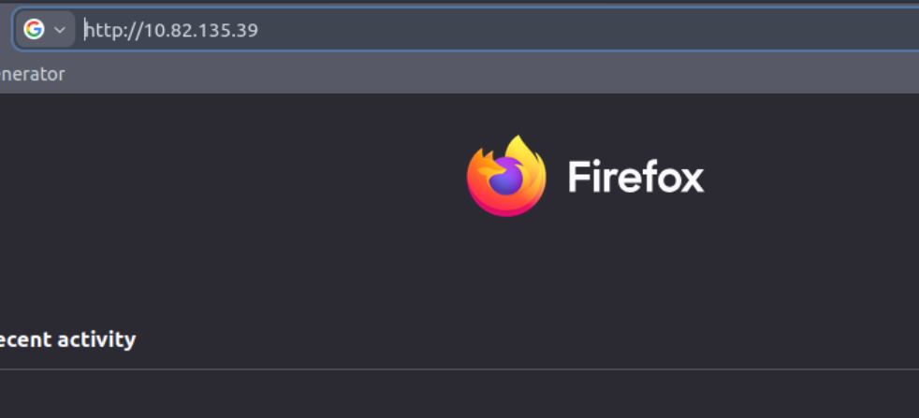

It is available in the Burp suite proxy page as a HTTP request that

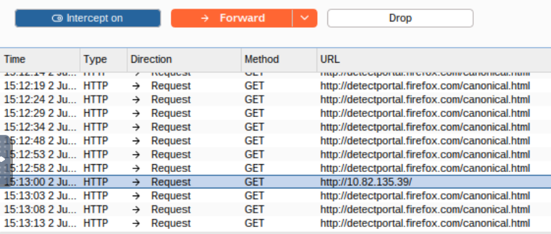

The target tab consists of 3 sub-tabs. Site map allows you to map out the web applications we are targeting in a treelike structure. Every page that is visited while the proxy is active will be shown on the site map. This can help gather data and map out API’s. The Issue definitions sub-tab gives a list of web vulnerabilities which can help reference vulnerabilities in reports or help describe them. Finally, the scope settings sub-tab allows for control over the target scope in Burp suite. It lets us include or exclude specific domains or IP addresses to define the scope of the testing which focuses on our target and not unnecessary traffic.

The Burp suite browser can be used to save time and hassle with setting up the proxy as the “Open browser” button in the proxy tab can be used to capture the traffic. The Scope sub-tab can be used by selecting the target tab > right clicking on our target from the list on the left > select add to scope. Burp will then prompt us to choose if we want to stop logging things that are out with the scope which is usually set to yes.

Practical

To show an example attack situation using Burp suite, we start by looking at the URL – http://10.82.135.39/ticket/. In a real-world pen test, I would look to use XSS and see if I can exploit the application. In the email field, special characters that are not found in email addresses are blocked. To get around this, I submitted a legitimate query as shown below.

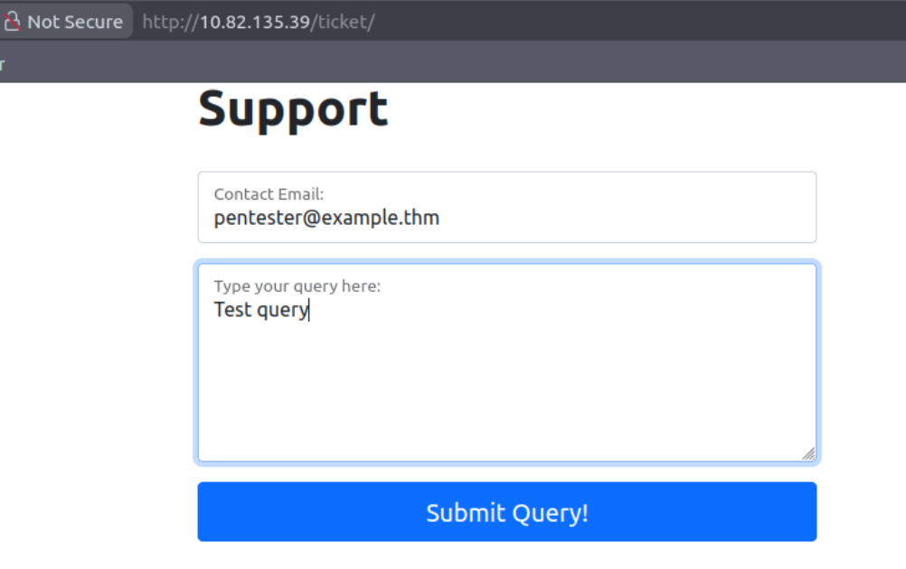

As the proxy was on and intercept was enabled, the HTTP request was in the proxy tab on Burp suite so I changed the email value to the XSS script.

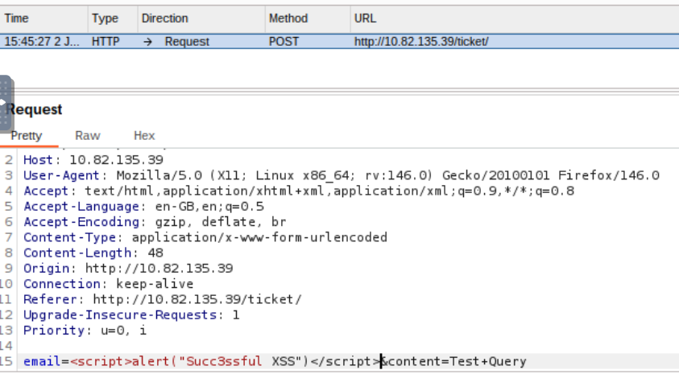

It needed URL encoded so CTRL+U was used and you can see the encoded version below

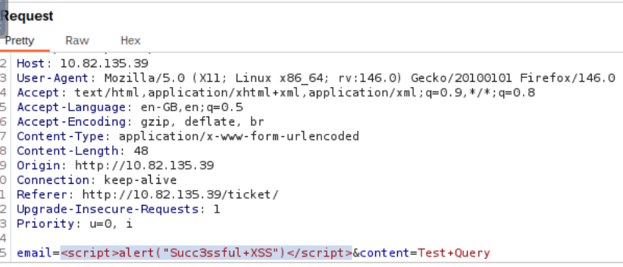

After it was encoded, the forward button was pressed and when I went back to the browser, the alert had popped up and the XSS attack had worked.

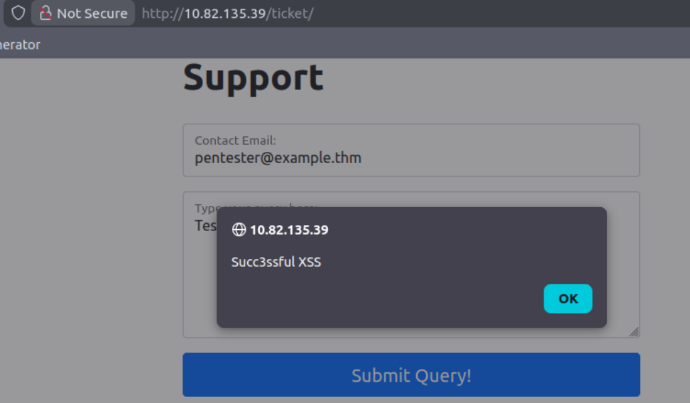

4. What I’ve learned

- What Burp suite is
- How Burp proxy works
- How the Target tab works
- How to manipulate a HTTP request and execute a XSS attack

